
full stack web development lab
Ms. Fiza Asmat

hassan shahid
241790
bscs 5c

LAB 04

Home Task:
Task 1 — Model the Catalog and Orders (Variables, Objects, Arrays):
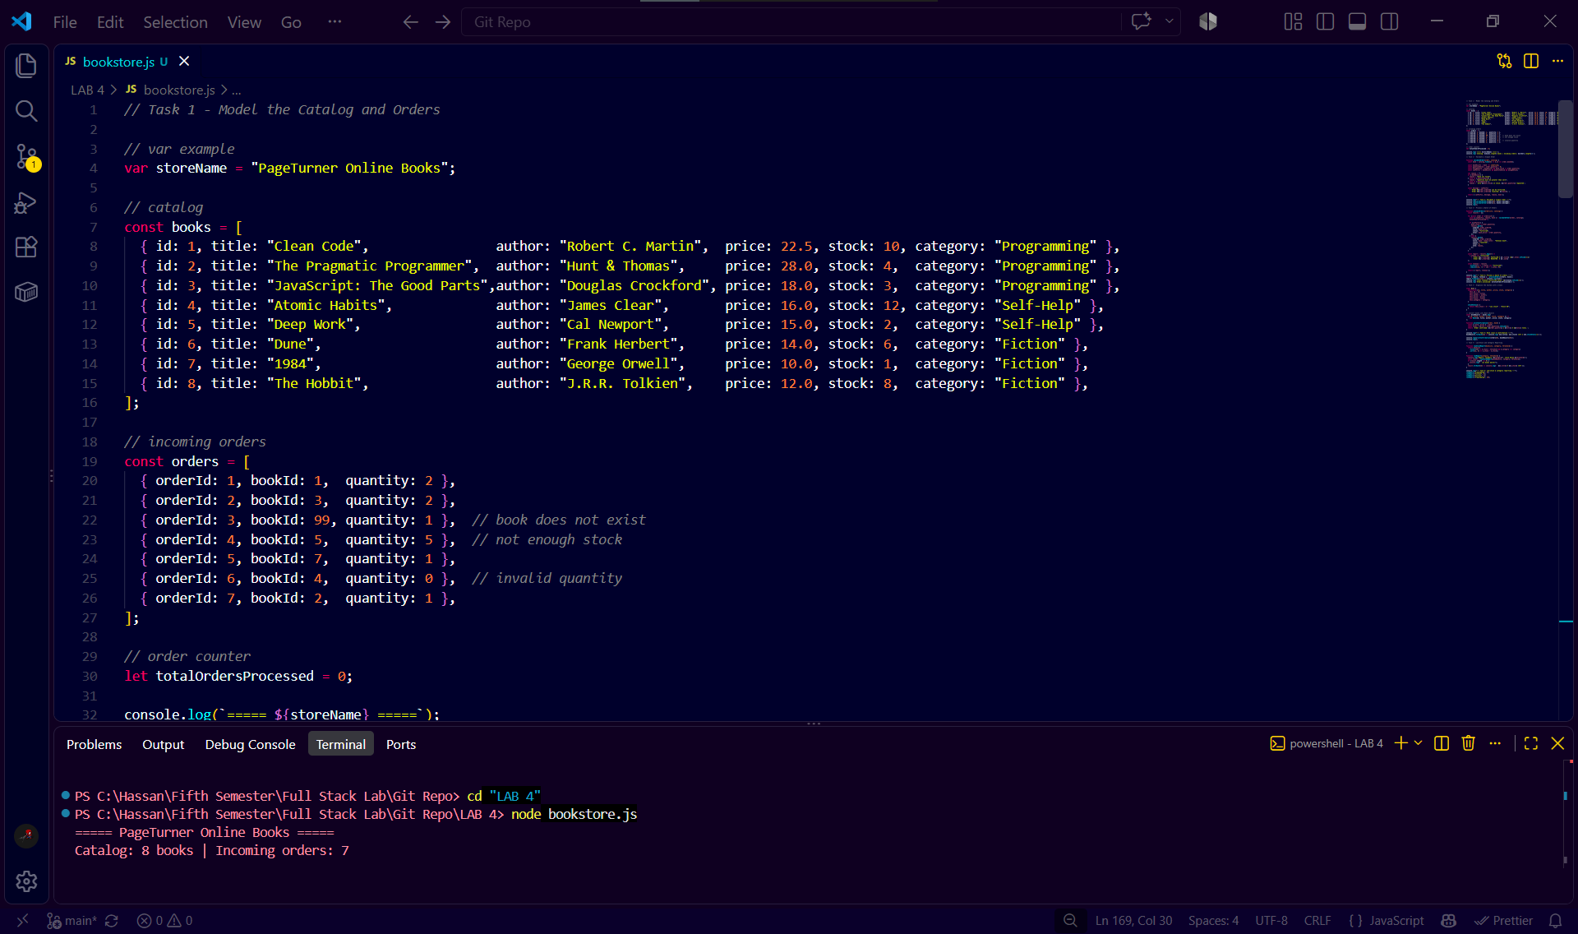
Task 2 — Validate a Single Order (Conditions, Operators, Ternary Operator):
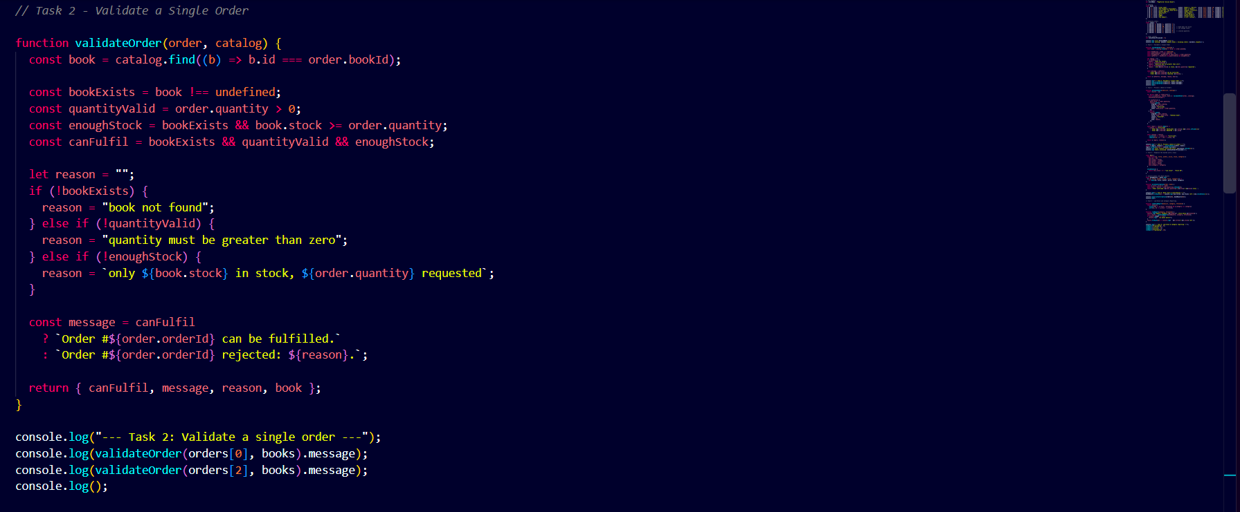
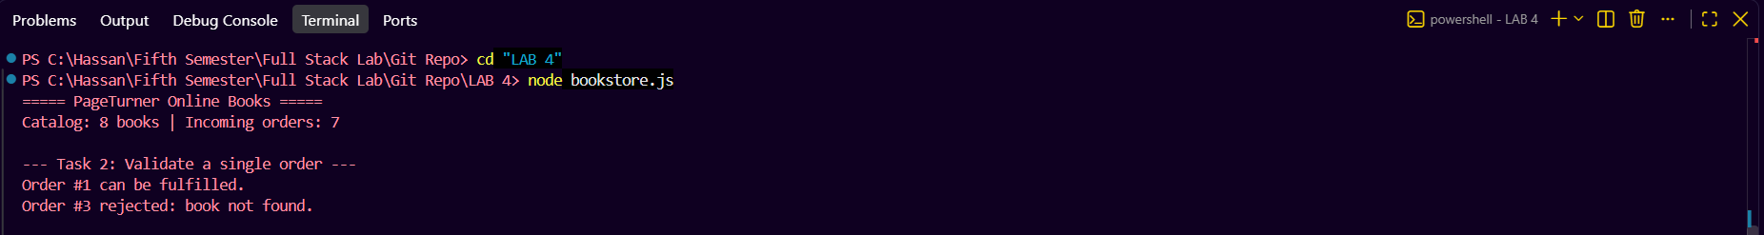
Task 3 — Process a Batch of Orders (Loops, Array Methods):
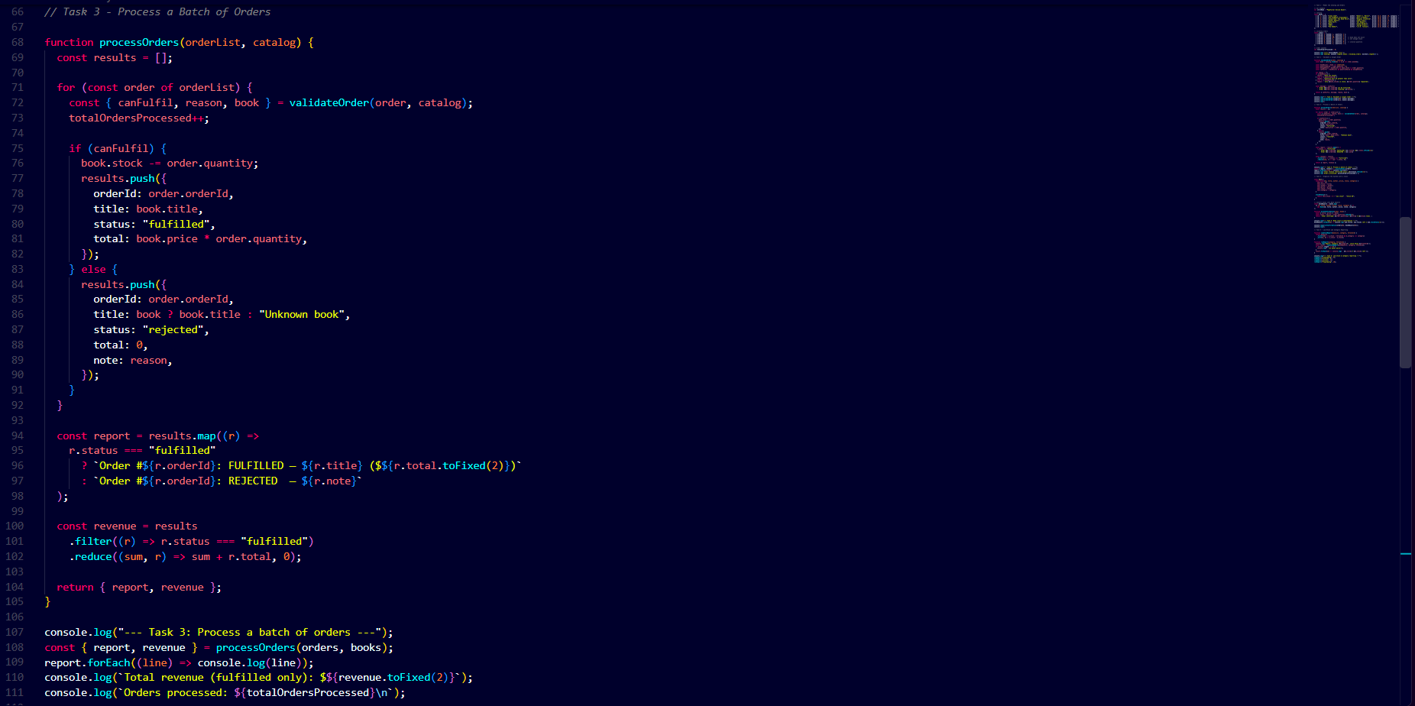
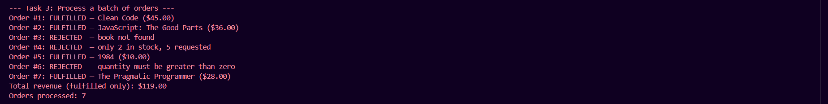
Task 4 — Organize the System with a Class (ES6 Classes, Destructuring, Template Literals):
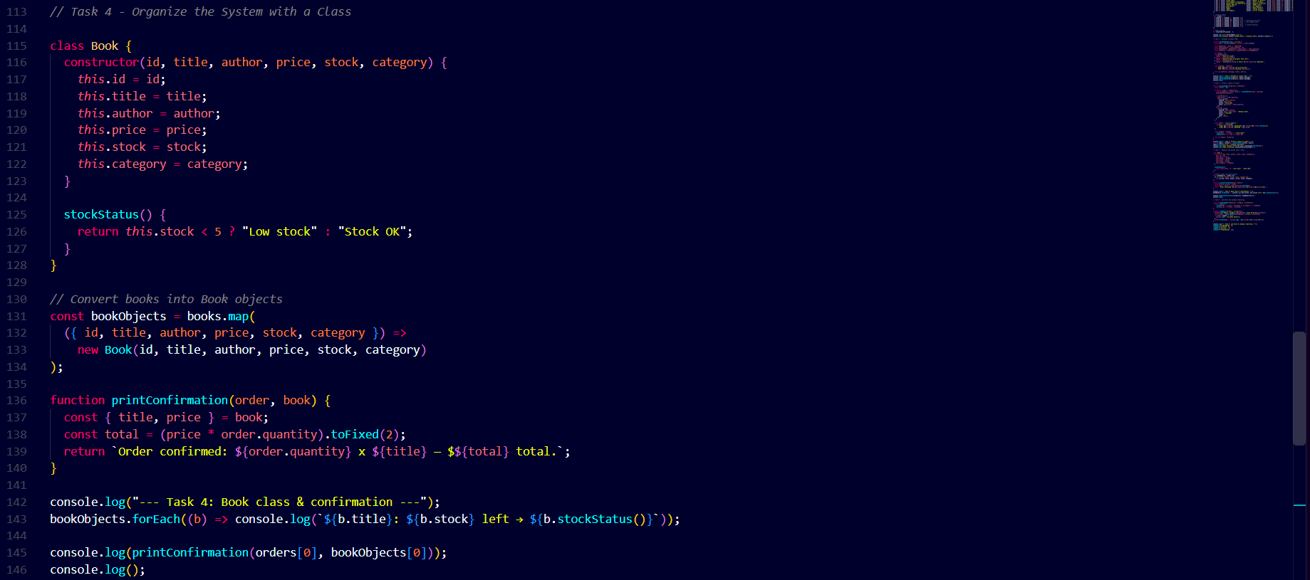
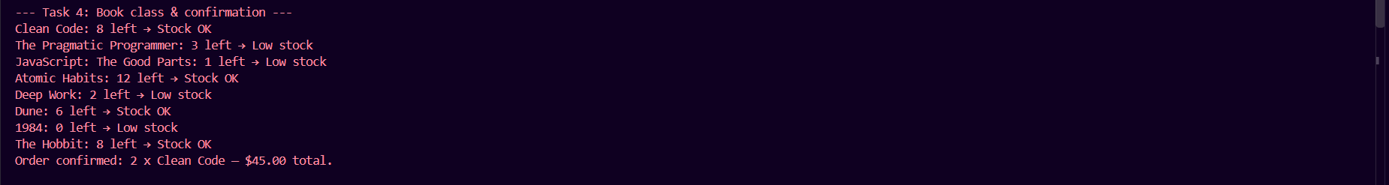
Task 5 — Low-Stock and Category Reporting (Combined Techniques):
